Lab – 8 – Pipeline

CodeCommit:
CodeCommit is a secure, highly scalable, managed source control service that hosts private Git repositories. CodeCommit eliminates the need for you to manage your source control system or worry about scaling its infrastructure. You can use CodeCommit to store anything from code to binaries. It supports the standard functionality of Git, so it works seamlessly with your existing Git-based tools.



CodeBuild:
AWS CodeBuild is a fully managed build service in the cloud. CodeBuild compiles your source code, runs unit tests, and produces artifacts that are ready to deploy. CodeBuild eliminates the need to provision, manage, and scale your build servers. It provides prepackaged build environments for popular programming languages and builds tools such as Apache Maven, Gradle, and more.

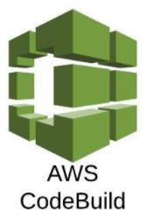

Code Deploy:
CodeDeploy is a deployment service that automates application deployments to Amazon EC2 instances, on-premises instances, serverless Lambda functions, or Amazon ECS services.



Code Pipeline:
AWS CodePipeline is a continuous delivery service you can use to model, visualize, and automate the steps required to release your software. You can quickly model and configure the different stages of a software release process. CodePipeline automates the steps required to release your software changes continuously.


Task Creating new IAM user.

- Create a new IAM user (Yourname-Pipeline) and group with policies:
“AdministratorAccess”, “AWSCodeCommitFullAccess”, & “AWSCodePipelineFullAccess”.
- Log back in as an IAM user.

PART 1: CodeCommit - Creating a repository on CodeCommit
Step 1: Create an Amazon CloudWatch Events to detect and react to pipeline execution state changes by sending an Amazon SNS notification (ADD SCREENSHOTS OF ALL STEPS)
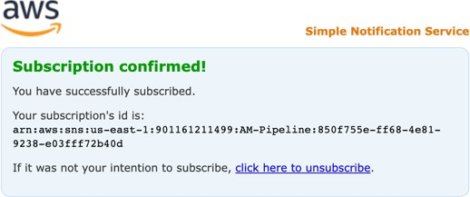

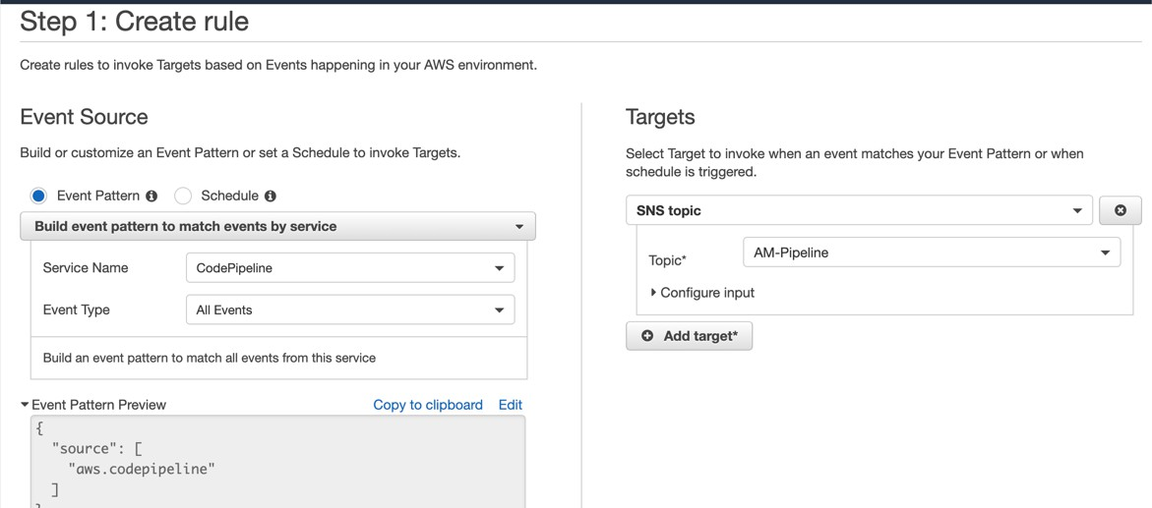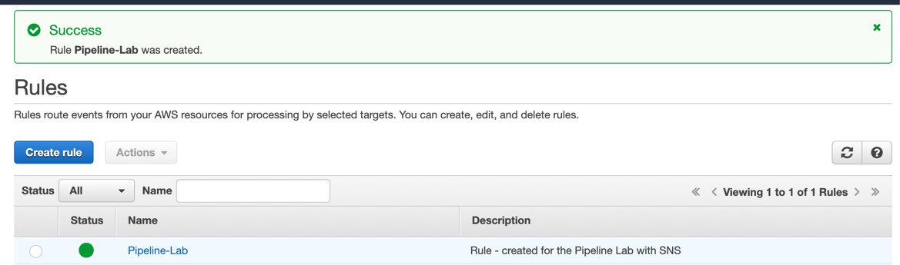

Step 2: Create a repository named <your-name-pipeline> on CodeCommit using AWS Console and connect using HTTPS (ADD SCREENSHOTS OF ALL STEPS)
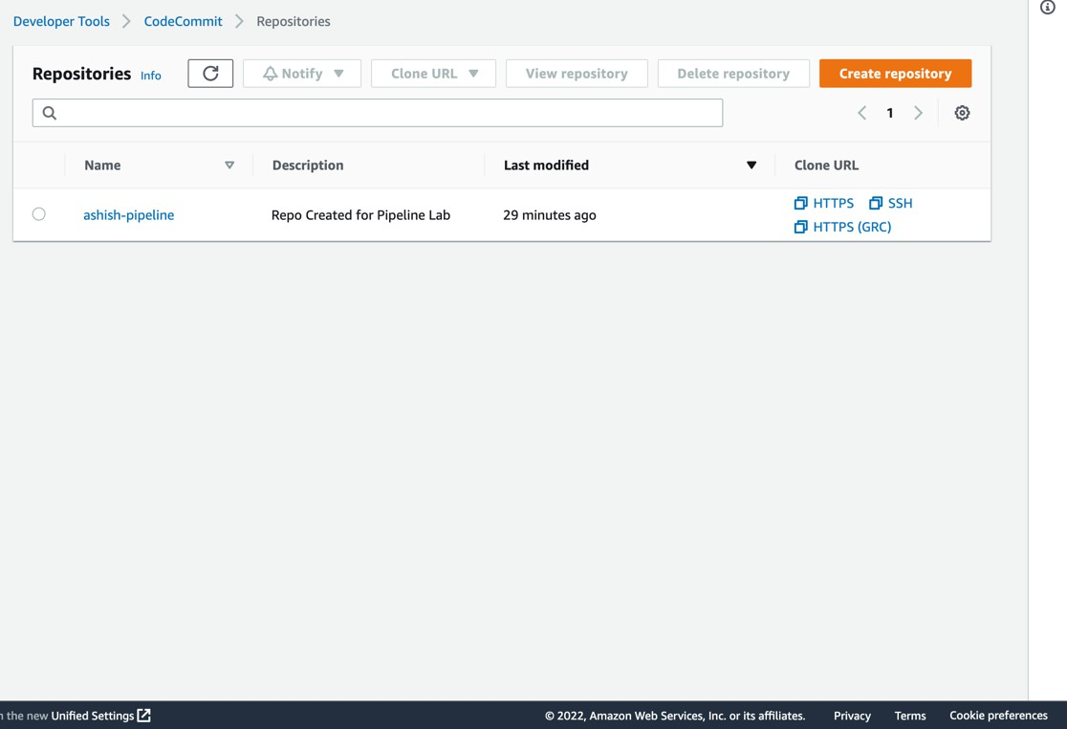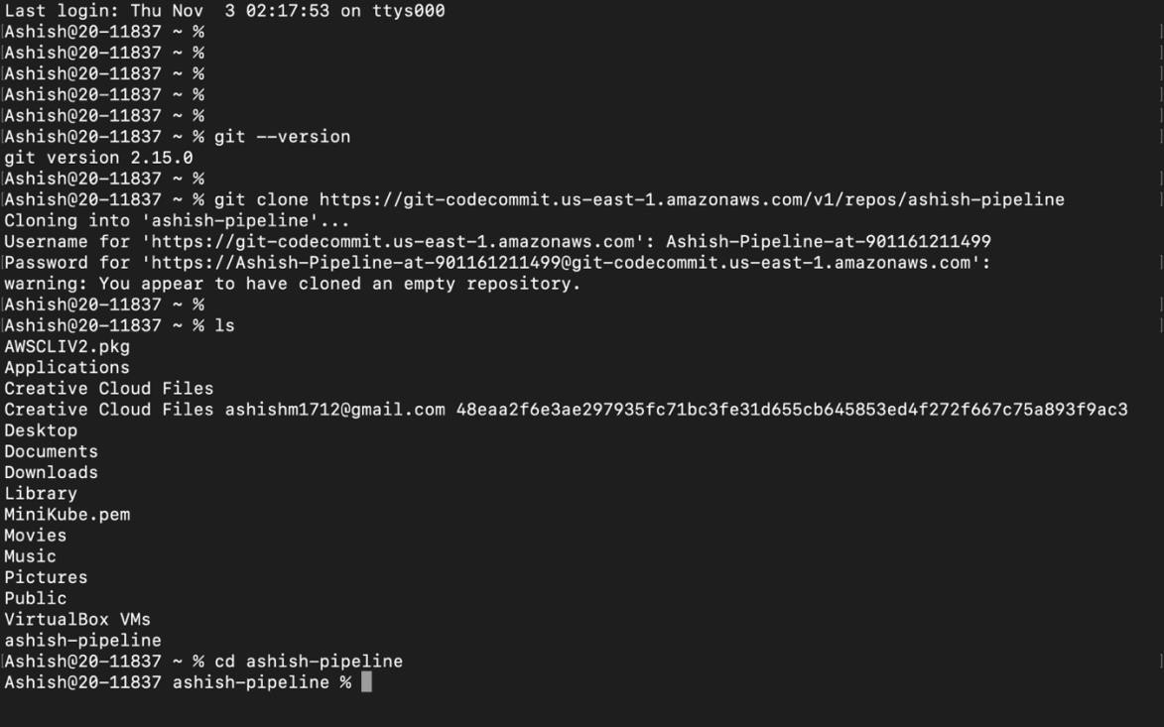

PART 2: CODEBUILD - Creating a new build in CodeBuild.
TASK 1: Create an S3 bucket named as <your-name-pipeline-lab> (ADD SCREENSHOT)

TASK 2: Create a buildspec.yml and appspec.yml file for your repository

(ADD SCREENSHOT)
Buildspec.yml:
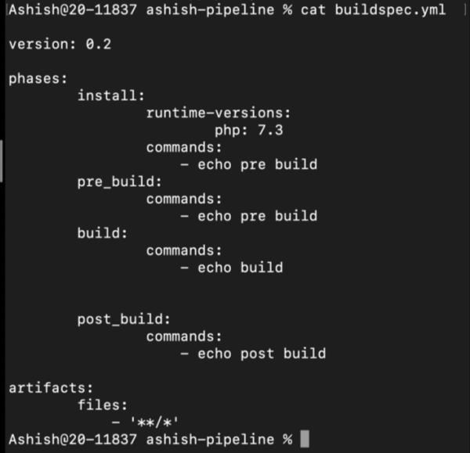
Appspec.yml:
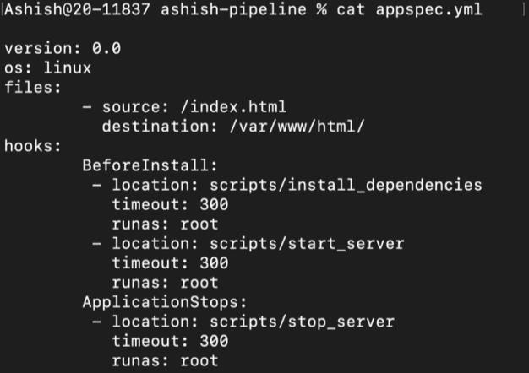
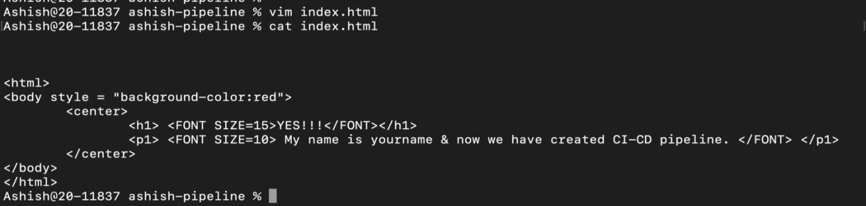

Theory questions:
Q) What is a buildspec file, in which stage will it be used & explain the file provided in this assignment
Q) What is an appspec file, in which stage will it be used & explain the file provided in this assignment
TASK 3: Create a new build in CodeBuild (ADD ALL SCREENSHOTS)
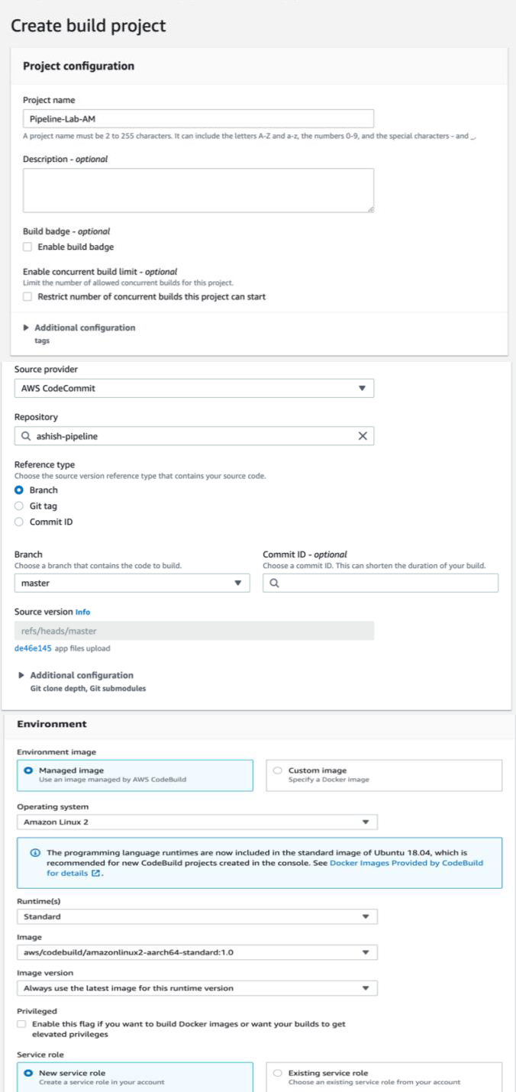

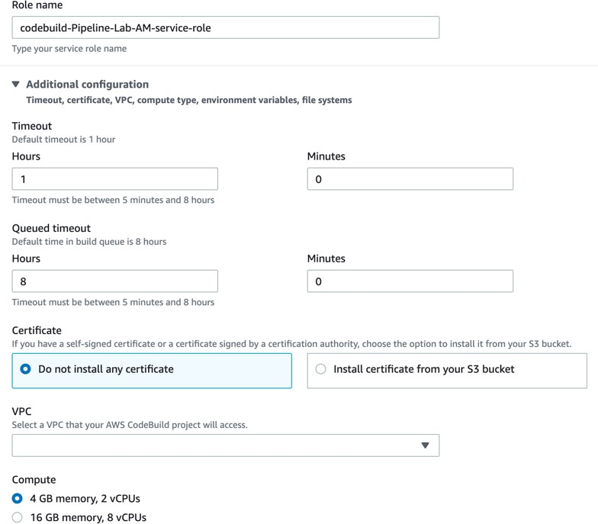
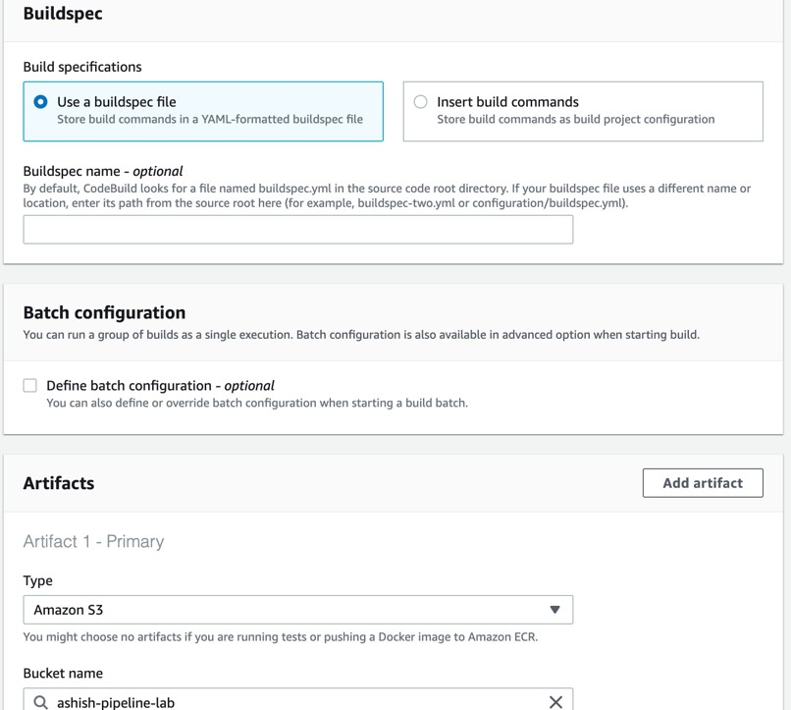

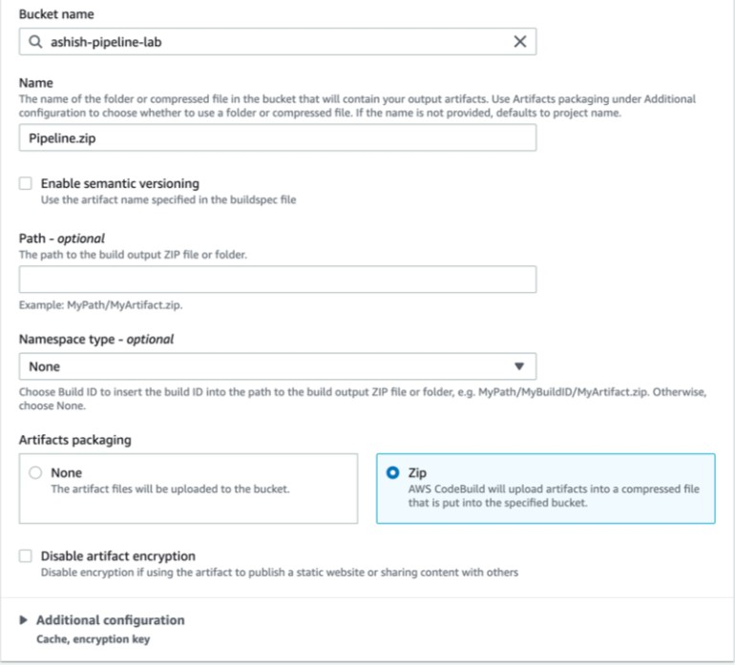
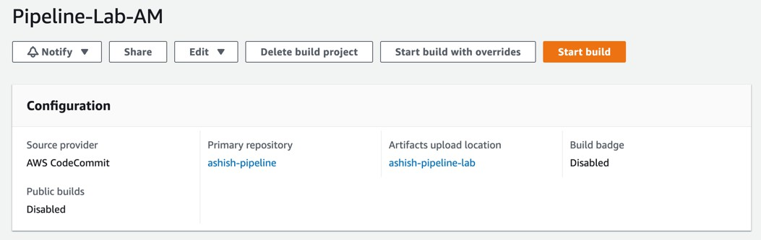
TASK 4: Start Build (ADD SCREENSHOT)
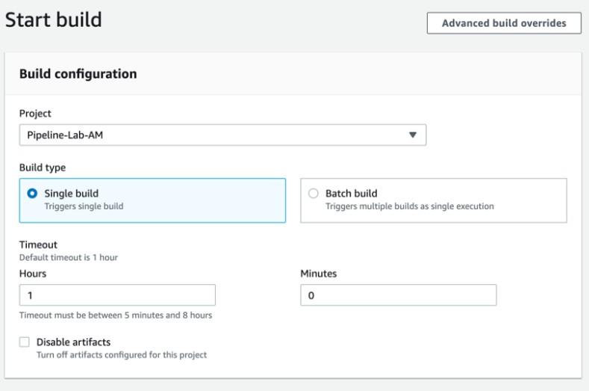

Check your build (ADD SCREENSHOT)
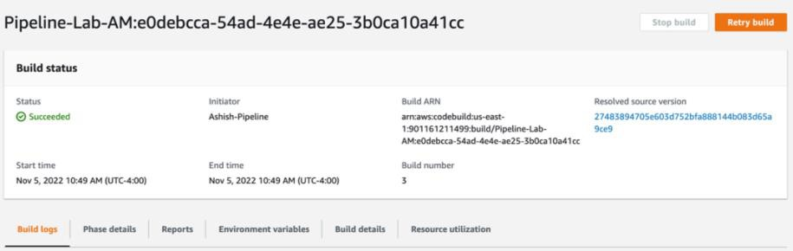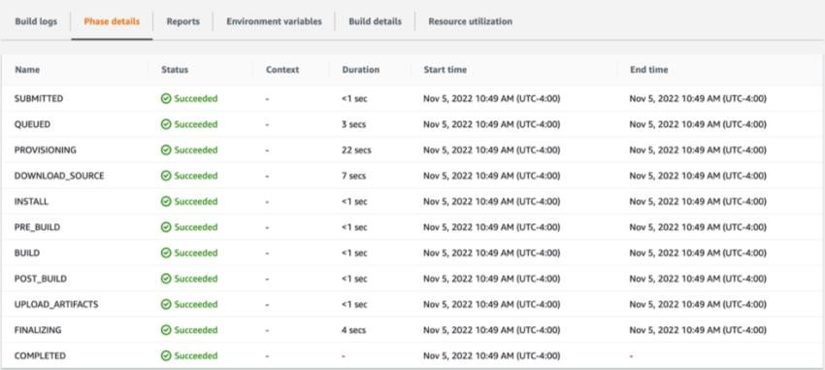

TASK 5: Check your artifact (ADD SCREENSHOT)
Theory question:
Q) What is an artifact? Explain it in general as well as about this lab.

PART 3: CODE DEPLOY
In this lab, we will create an Elastic Beanstalk application which will be used later in the CodeDeploy stage while adding stages in the pipeline in the next part

Creating Beanstalk App
TASK: Create an Elastic Beanstalk application with PHP as your platform (Select defaults for platform branch & version) and use the application code from s3 (ADD SCREENSHOT)
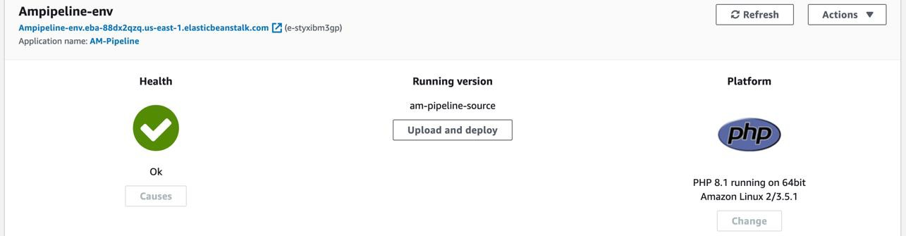

PART 4: CODE PIPELINE
Creating end to end pipeline using CodePipeline

TASK 1: In this task, now we put together all the stages that we created in parts 1, 2, and 3. Select the appropriate and correct option for each stage to build the pipeline.
(ADD SCREENSHOTS OF EACH AND EVERY STEP)
TASK 2: Meanwhile the pipeline is getting created, you should receive notifications from CloudWatch Alarms indicating the stages being created. (ADD SCREENSHOTS)
TASK 3: Pipeline created (ADD SCREENSHOTS)
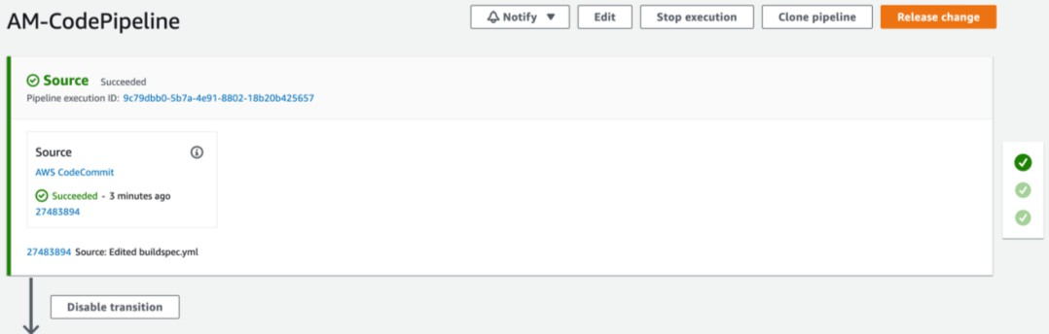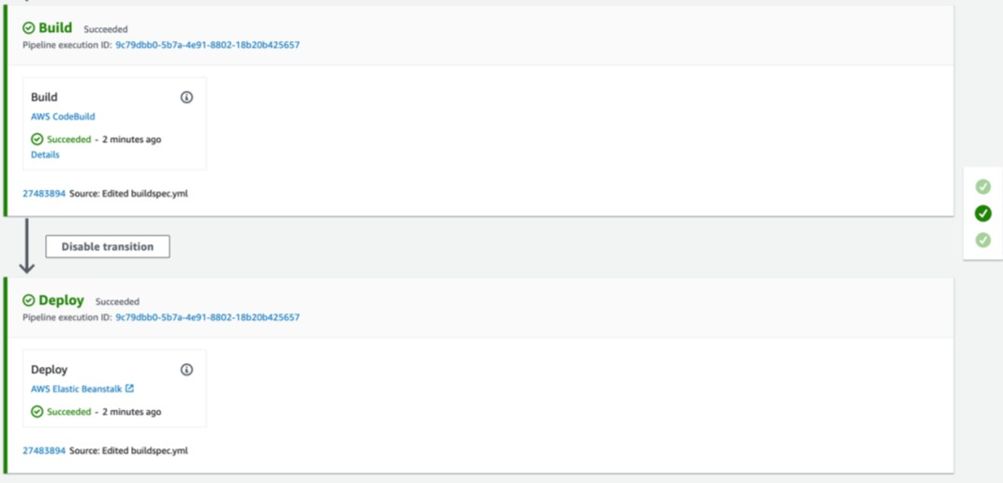

TASK 2: Now verify your deployment (ADD SCREENSHOT)
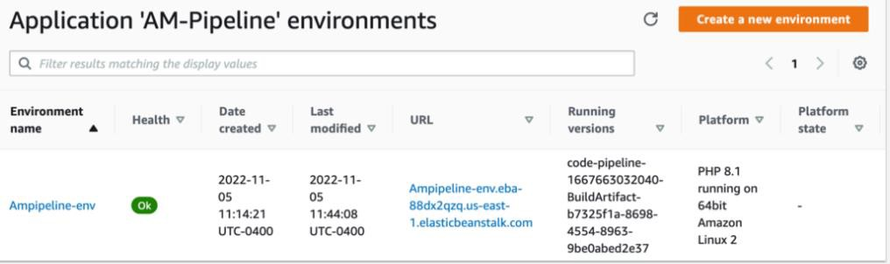

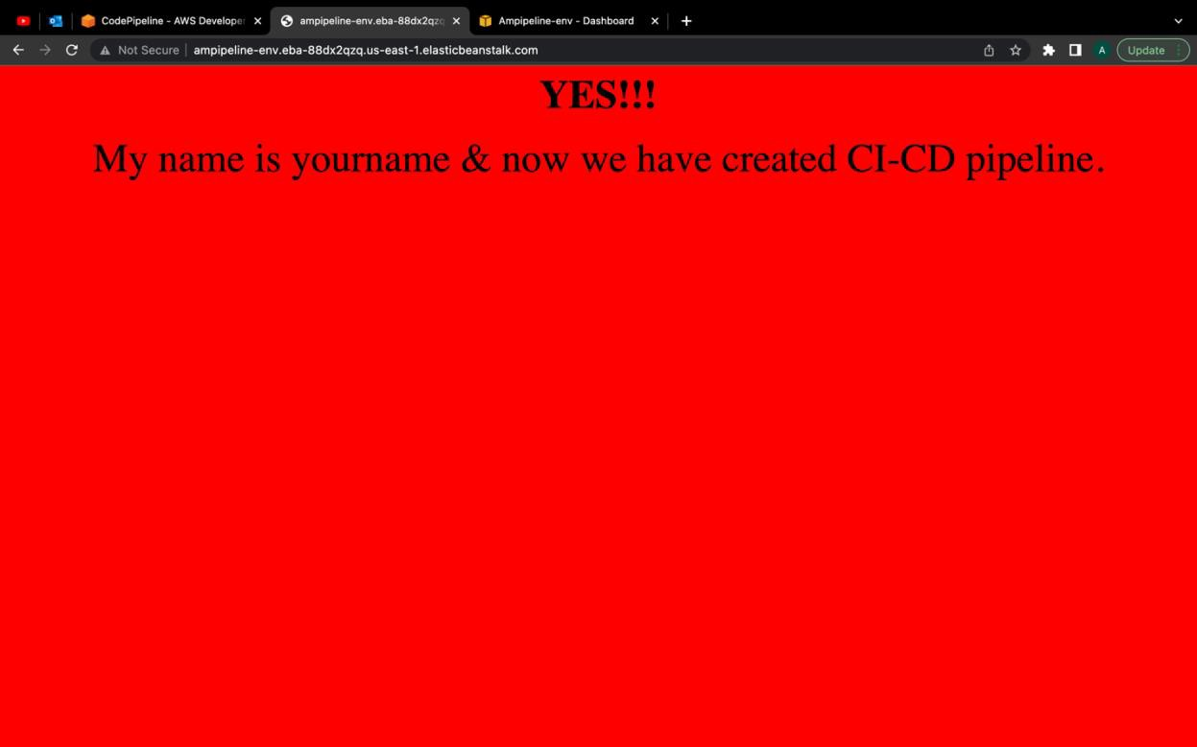

Theory question:
Q) Explain how a pipeline works in detail

PART 5: Triggering pipeline
We will trigger our pipeline by making a small change to demonstrate how a pipeline automates the whole process.

TASK 1: Make changes to your index file (ADD SCREENSHOT)
TASK 2: As soon as your pipeline is triggered, you must have started to receive notifications from CloudWatch via SNS (ADD SCREENSHOTS)

TASK 3: Check your pipeline (ADD SCREENSHOT)
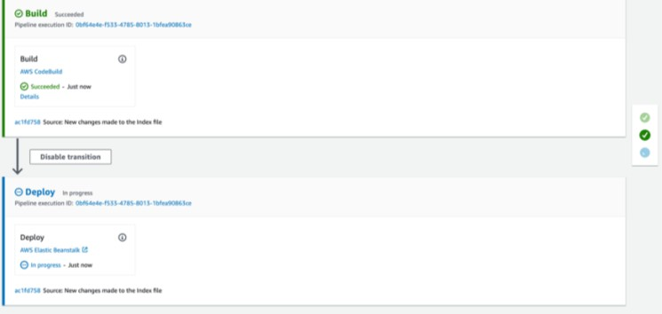

TASK 4: Check whether your pipeline is deployed successfully (ADD SCREENSHOT)
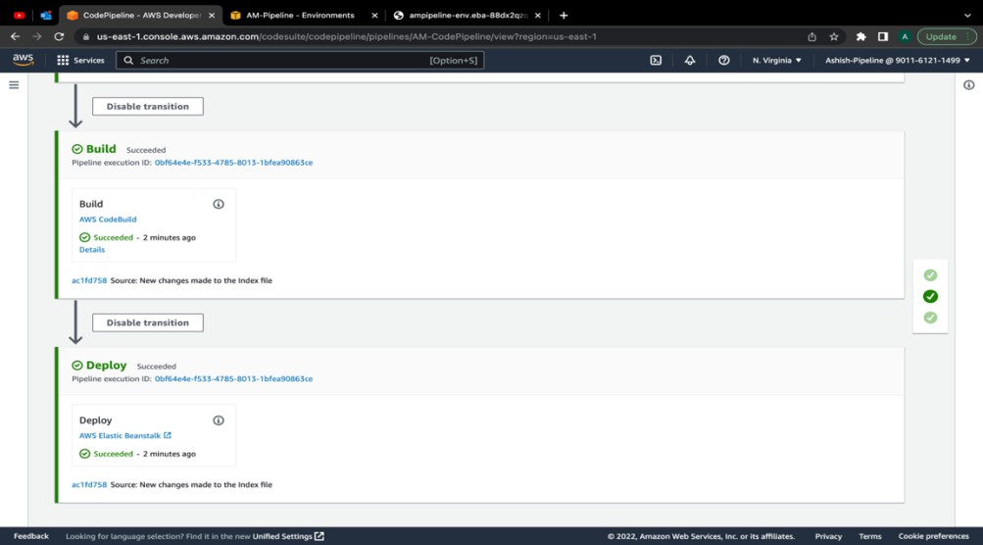

Theory question:
Q) Explain how you triggered your pipeline and how the whole process of building till deploying the pipeline was done.
TASK 5: Verify your deployment & check build history. (ADD SCREENSHOT)
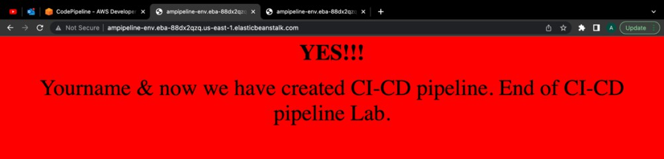

CONCLUSION: We have successfully implemented an end-to-end CI/CD Pipeline using AWS CodeCommit, CodeBuild, CodeDeploy, and CodePipeline.

Terminate and delete everything in the user you have created.
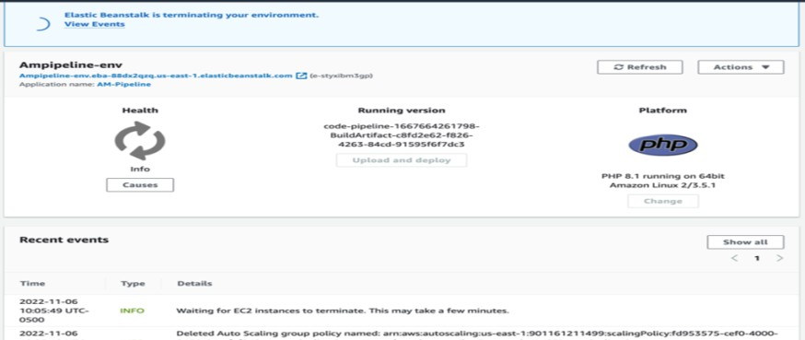

End of Lab

